Assignment: Day-3 IP Addressing

1. IPv4 vs IPv6
IPv4 | IPv6
32-bit, dotted decimal | 128-bit, hexadecimal
~4.3 billion addresses | Huge address space
Supports NAT commonly | NAT usually unnecessary
Header is simpler but less extensible | Improved header and auto-configuration

2. Static IP Assignment
Device | IP | Subnet Mask | Default Gateway
Laptop | 192.168.10.10 | 255.255.255.0 | 192.168.10.1
Phone | 192.168.10.11 | 255.255.255.0 | 192.168.10.1
Smart TV | 192.168.10.12 | 255.255.255.0 | 192.168.10.1
Printer | 192.168.10.13 | 255.255.255.0 | 192.168.10.1

3. /27 Subnetting
Borrowed bits: 3
Valid subnets: 8
Hosts per subnet: 30
1) 192.168.1.0 - 192.168.1.31 | Hosts: 192.168.1.1 - 192.168.1.30
2) 192.168.1.32 - 192.168.1.63 | Hosts: 192.168.1.33 - 192.168.1.62
3) 192.168.1.64 - 192.168.1.95 | Hosts: 192.168.1.65 - 192.168.1.94

4. IP Calculation
IP: 10.0.5.17
Subnet Mask: 255.255.255.0 (/24)
Network: 10.0.5.0
Broadcast: 10.0.5.255
Valid Hosts: 10.0.5.1 - 10.0.5.254

5. Verification

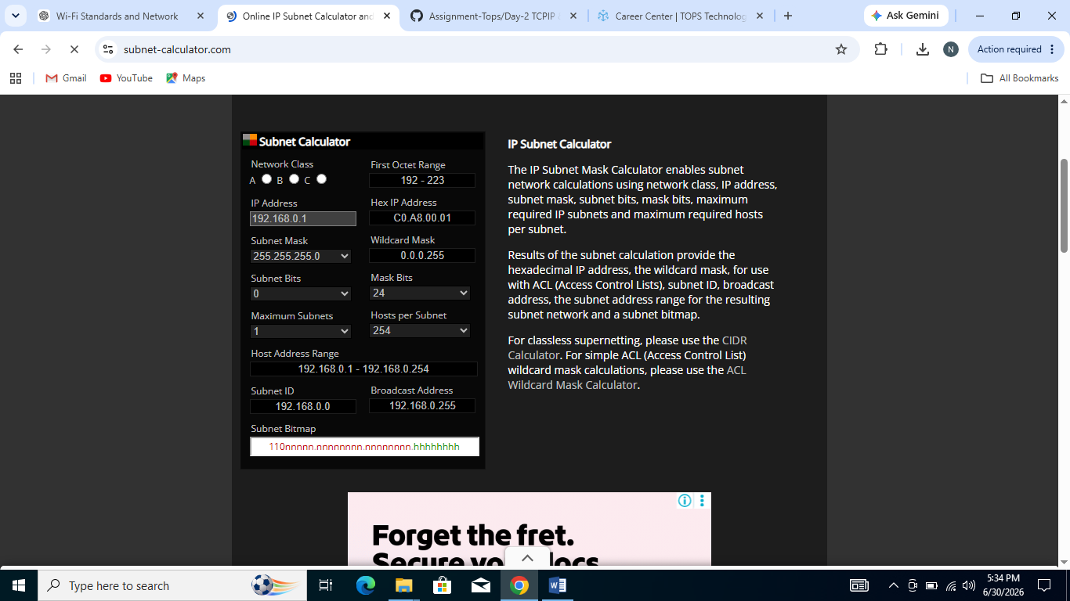
Verification Statement:
The results from the online subnet calculator matched my manual calculation exactly. Both showed the same network address, broadcast address, usable host range, and CIDR notation.

